Detailed Material List

When you first open your kit, please verify the following items are included. If you need assistance identifying items, use the Website Kit Resource Link to view the Detailed Material List with descriptions and pictures.
These are the required items included in the kit provided in 3 separate bags:
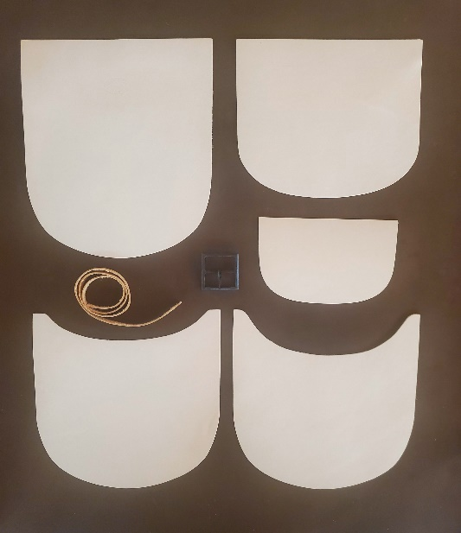
- Kit Overview Sheet
- Bag 1: Stitching Clamp
- Bag 2: Leather: Eight Pre-cut Pieces
    - Body Back
    - Front
    - Flap
    - Internal Divider (Use for Option A Flat-Sewn Bag)
    - Internal Back Pocket
    - Billet Strap
    - Strap with Buckle Turn
    - Welt (Use for Option B Turned Bag)
- Bag 3: Tools / Buckle
  - Dividers
  - Stitching Awl
  - 4-Cord Linen Thread
  - 2 Harness Needles
  - Beeswax
  - Period-correct, Die-forged Buckle

Additional Resource List:
Other common tools required, but not included in the kit are:
- Knife / Box Cutter
- Ruler
- Contact Cement, Glue, Tacks, or Binder Clips**
Optional resources that can be used, but are not required and not included in the kit:
- Leather Dye (see Alternative Customization Options for Dying Leather)

** Note: Binder clips work well to hold leather in place, especially when working with a welt; however, be aware that the metal in these clips can react with the tannings of the leather when it is moist or wet causing the contact points to turn black. Some people line their clips with thin pieces of leather to eliminate this problem.

Body Back Body Front Flap Internal Back Internal Divider
Pocket

Welt

